**CALA BIRIOLA**

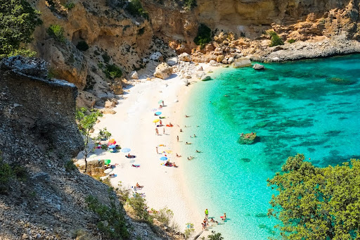Cala Biriola or Cala Biriala is a pretty cove with a landslide origin that rises at the foot of the limestone cliff, typical of the entire territory of Baunei. The beach is formed by white pebbles with rounded contours: the merit of this slow and incredible work goes to the surrounding.